**Herguan University**

**CS565 - .NET Programing - Fall *–* 2015**

**Prof: Wiselin Mathuram**

**Report –** Read and write Database

**Name: Anupa Mathew**

**STID: 142072**

**Required Tools:**

* Visual Studio (2010 and UP)
* SQL Server (I’m using SQL Server 2014R2 )
* Database (For Sample Data)

**Step1:**

**Creating a Sample Registration Table**

Create Database Student

Go

CREATE TABLE Registration(

FName Varchar(9),

LName Varchar(9)

);

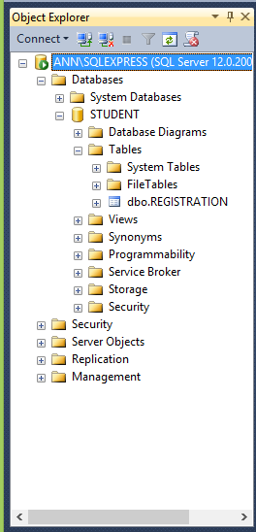

**Step2:**

**Creating Connection to database from Visual Studio**

Connect to database through Data Source Configuration Wizard.

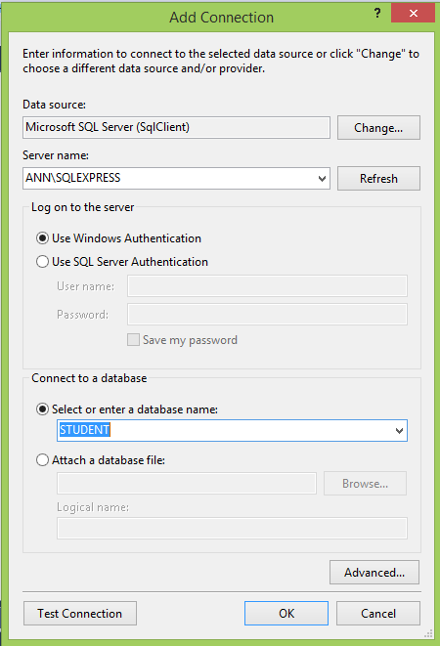

**Step3:**

**Create New Project in visual studio**

Create the web form for displaying student data. Right-click your project, and Add a New Item. Select the Web Form, and name it Students.aspx.



